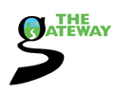
Gateway to your future
Volunteer programme
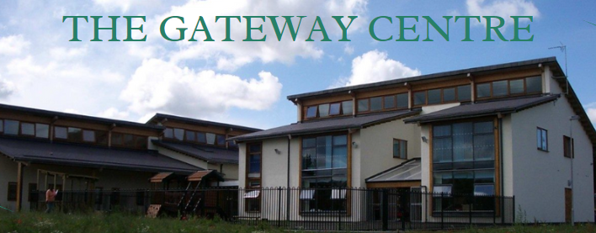

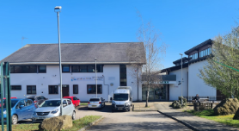
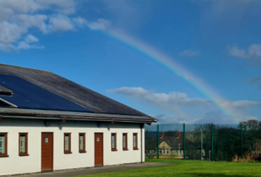

Our aim is to have a variety of quality volunteer positions within the community. Allowing volunteers to work alongside skilled individuals and receive quality mentoring support to help volunteers achieve their unique goals.

VOLUNTEERS RIGHTS AND RESPONSIBILITIES
RIGHTS
- To have someone to talk to about the work
- To be appreciated
- To know who to go to with a problem
- To get something for themselves from volunteering
- To make mistakes and learn from them
- To be confident enough to say NO
- To be aware of the selection process
- To know what their rights are
- Not to be out of pocket
- To be offered training
- To develop and change their job
- To have safe working conditions
- To be free of discrimination on the grounds of race, gender, sexuality, disability, age
- Etc.
- To enjoy being involved in voluntary work
- To have adequate insurance cover

RESPONSIBILITIES
- To do the job reliably and as agreed
- To do it in a way which corresponds to the aims, values and policies of the gateway
- To be honest
- To be punctual
- To maintain confidentiality
- To demonstrate respect for diversity

Volunteer Application Form
This form is not intended as a contract or contract of employment with any of its volunteers, at any time now or in the future. The information in this application will be treated as confidential.
Personal Details
Name:
Address:
Home Phone:
Mobile Phone:
Email: Date:
Please complete the questions as fully as possible.
References:
Name: Name:
Address: Address:

Phone no: Phone no:
Email address: Email address:

What are you wanting to gain from volunteering with us?

Do you have any previous experience as a volunteer?
3. What previous voluntary work, employment or studies have you done that might help you in your voluntary work?

Availability
What times are you available to volunteer with us?
Monday | Tuesday | Wednesday | Thursday | Friday

Could you please tell us, in as much detail as possible your last jobs, training, hobbies and/or interests:

What do you wish to achieve in the long term i.e. further training, change of career or confidence building:

When you have filled out the form we will try to find a suitable placement and will contact you with more information. Thank you.

Sign: Date:

Where did you hear about us?

Volunteer Roles Include:
Cafe: Serving customers, handling cash, preparing food
Training given: basic food hygiene certificate
Gardening: General garden work, digging, weeding and planting.
Office: The opportunity to experience a different working environment, learning new skills and confidence building. Duties include answering the phone, taking messages, IT, filing and signposting people to other organisations etc.
Handyman: General DIY duties around the Community Centre such as painting, general maintenance or any other skill you can contribute to the centre.
JOB CLUB: supporting people with job search and CV’s etc.
Publicity/promotion and Creative Display: creating flyers, newsletters and posters to promote community activities and events, posting flyers/newsletters, updating Facebook and our webpage. Creating board displays within the community centre.
IT Support: supporting people 1-1 to increase their computer skills.
Setting up your own group: we encourage and welcome people who identify a need within the community to set up their own groups and help them with funding.
Member of the RCA Board of Committee: be part of a group of local people and professionals who oversee the running of the organisation. We are looking for people with management experience, funding raising, attend monthly meeting etc.

We are searching for volunteer opportunities all the time so if there is nothing here you fancy doing give us your details and we will get back to you if we find a suitable place.
Gateway to your Future
Volunteer agreement
As a volunteer you are an important and valued part of Ravenscliffe Community Association. We hope that you enjoy volunteering with us and feel a full part of our team.

This agreement tells you what you can expect from us, and what we hope from you. We aim to be flexible, so please let us know if you would like to make any changes and we will do our best.

We, Ravenscliffe Community Association, will do our best:
• to introduce you to how the organisation works and your role in it and to provide any training you need.
• to provide regular meetings with the Volunteer Support Team so that you can tell us if you are happy with how your work is organised and get feedback from us.
• to respect your skills, dignity and individual wishes and to do our best to meet them.
• to pay your travel and meal costs up to our current maximum*.
• to consult with you and keep you informed of possible changes.
• to insure you against injury you suffer or cause due to negligence*.
• to provide a safe workplace*.
• to apply our equal opportunities policy
• to apply our complaints procedure if there is any problem

I, [ ], agree to do my best:
• to work reliably to the best of my ability, and to give as much warning as possible whenever I cannot work when expected.
• to follow Ravenscliffe Community Association’s rules and procedures, including health and safety, equal opportunities and confidentiality.

*More details on these issues are provided in the volunteer policy.

Note: this agreement is in honour only and is not intended to be a legally binding contract of employment.

